Joseph Lee (jhl2226)

1. What implicit claim about causality does Obama's "cycle of crime" theory assert?

Obama's "cycle of crime" theory asserts that incarceration causes future criminal behavior. This causal claim assumes that the experience of incarceration leads to increased recidivism through mechanisms such as economic exclusion and social influence effects. Importantly, the theory also assumes that the causal relationship is not reversed. That is, it does not reflect a situation where individuals who are inherently more likely to reoffend are simply more likely to receive prison sentences in the first place. By rejecting this reverse causality, the theory underscores the idea that incarceration itself plays an active role in shaping future criminal behavior, rather than considering it a response to an individual’s pre-existing likelihood of committing further crimes.

2. Your friend has an ingenious idea. He/she has detailed case data about criminal sentencing in a large jurisdiction for everyone charged with a felony. The data includes the length of the prison sentence (in days), and whether the person was convicted of a *second* crime after he/she was out ("recidivism"). This seems to be what the "cycle of crime" theory is talking about.   
  
The proposed research design is: Run a regression whose outcome is recidivism and whose main explanatory variable is the length of the prison sentence. React your friend's research design.

The proposed research design of regressing recidivism on the length of prison sentences addresses a key aspect of the "cycle of crime" theory, but it does not address the alternative explanation involving reverse-causality. While this approach could reveal an association between sentence length and recidivism, it cannot establish whether incarceration itself causes future criminal behavior or whether individuals who are inherently more likely to reoffend tend to receive longer sentences. This is because the length of prison sentences is likely influenced by unobserved factors such as the severity of the crime, the defendant’s criminal history, or judicial discretion, all of which may also predict recidivism. Without addressing these confounding variables, the design cannot make a valid claim about the causal direction of the association between recidivism and the length of the prison sentence.

4. Perform a balance test. Does the judge's party really seem to be randomly assigned?

Table 1: Comparison of Defendant Characteristics by Judge's Party Affiliation

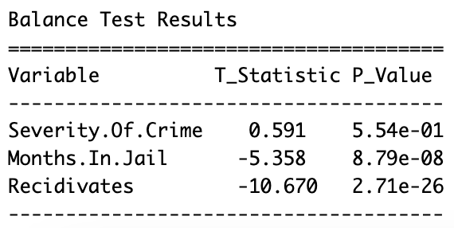

The balance test indicates that judge assignment is likely random with respect to pre-existing defendant characteristics, as evidenced by the non-significant difference in severity of crime between Republican and Democrat judges. This supports the assumption of random assignment. Additionally, the significant difference in months in jail does not raise concerns about random assignment as this is not a pre-existing defendant characteristic. Instead, it suggests that judges' political affiliations influence sentencing length, satisfying the relevance condition for using political affiliation as an instrumental variable. The exclusion restriction is plausible, as judges' political affiliation is unlikely to directly affect recidivism beyond its impact on sentencing. Therefore, the judge's political affiliation can serve as a valid instrument for estimating the causal effect of sentence length on recidivism.

5. Describe in words the “first stage” of the IV design. Then, create a publication-quality table for the first stage only.

The first stage of the IV design tries to examine how the instrument, **judge's political affiliation (Republican vs. Democrat)**, affects the variable which I want to make a causal statement about, **sentence length (Months in Jail)**. We do this by regressing sentence length (x) on judge’s political affiliation (z). This regression allows us to assess the strength of the relationship between x and z. To ensure the relationship is not confounded by other factors, the regression includes a control for **severity of crime**, which could independently influence sentence length but is unrelated to judge assignment due to randomization. This setup ensures that the first stage isolates the causal effect of judge's political affiliation on sentence length.

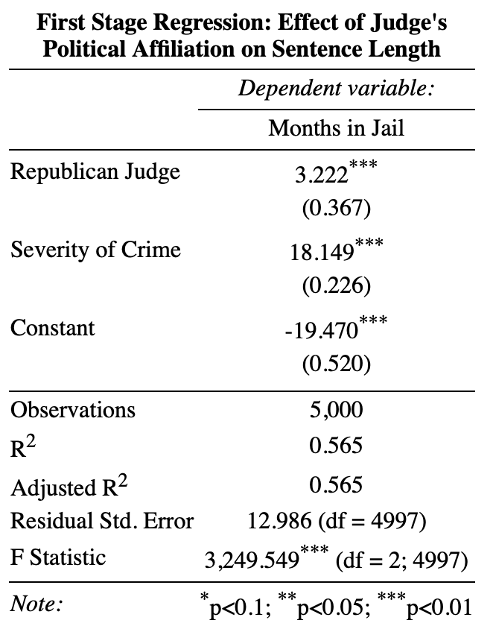

6. Interpret the coefficient on your instrument from the first stage.

The coefficient on the instrument, judge’s political affiliation, in the first stage is 3.222, and it is statistically significant (*p* < .001). This coefficient means that, on average, defendants assigned to Republican judges receive sentences that are approximately 3.222 months longer compared to those assigned to Democrat judges, holding the severity of the crime constant. This result demonstrates that judge political affiliation strongly influences sentence length, and thus that it is a strong instrument.

8. Calculate the ratio of the reduced form.

0.1426641/3.221876 = 0.04427982

9. Now complete the IV regression and make a publication quality table of the second stage. Use the setup below.

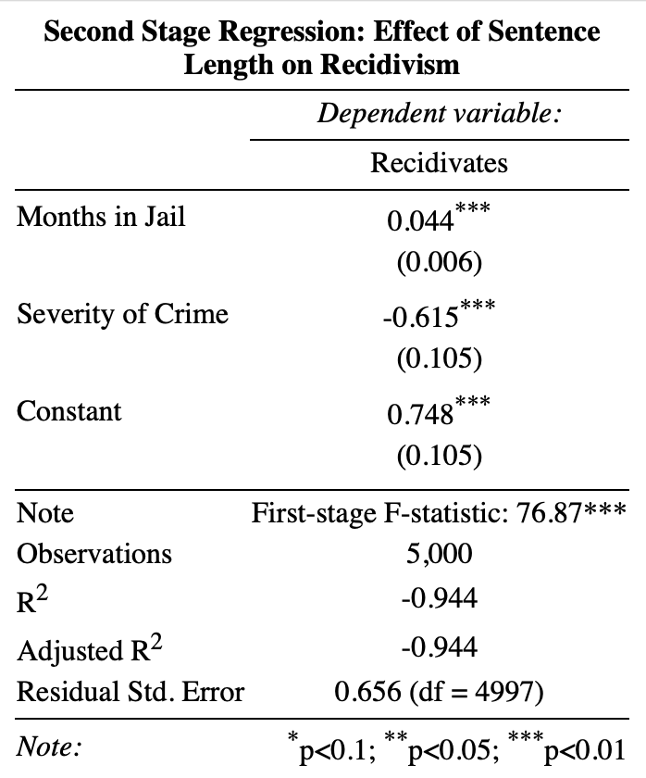

10. State the F-stat in your writeup. It does not need to go into your table (although, in an actual publication it would). Is it above the conventional threshold?

The results from the second-stage IV regression indicate that the sentence length has a statistically significant positive effect on the likelihood of recidivism. The first-stage F-statistic for the instrument, judge's political affiliation, is 76.87 and highly significant, confirming the strength of the instrument and the validity of the IV approach. It is above the conventional threshold of 10. These results support the "cycle of crime" hypothesis, suggesting that longer incarceration may causally increase reoffending, potentially due to mechanisms such as economic exclusion or criminal socialization during imprisonment.

11. Compare your answer to question #8 (above) to the IV coefficient in #9.

The coefficient I obtained in question 9 is identical to my answer for question 8.

12. Complete these sentences

Always-takers:

In the research design above (using randomized judges), the always-takers are the defendants who are always given long sentences no matter which judge they are assigned to.

Never-takers:

The never-takers are the defendants who are always given short sentences (or not sentenced at all), no matter which judge they are assigned to.

Compliers:

The compliers are the defendants who are given longer sentences when they are assigned to a Republican (vs. Democrat) judge.

Defiers:

Defiers are the defendants who are less likely to receive longer sentences when assigned to a Republican judge.

13. Comment on the monotonicity assumption and the possibility of "defiers" in this setting.

The monotonicity assumption in this setting assumes that being assigned to a Republican judge either increases or has no effect on the likelihood of receiving a longer sentence for all defendants convicted of Class E felonies. While the assumption generally holds, there could certainly be defiers in specific types of cases where Democratic judges may be stricter than Republican judges. For example, Democratic judges could impose harsher sentences for Class E felonies related to environmental crimes, hate crimes, labor violations, or corporate misconduct, reflecting their focus on social justice and accountability. If such cases do exist, they would violate the monotonicity assumption.

14. In your dataset, what types of defendants are compliers?

In this context, compliers are likely defendants whose cases do not fall under rigid judicial philosophies but are instead subject to variability based on the judge's discretion and interpretation of the law. These cases might involve offenses at the boundaries of leniency and strictness, such as misdemeanors or less severe Class E felonies, where sentencing outcomes are more flexible and influenced by individual judicial tendencies.

15. Does the cycle of crime hypothesis appear to be true for the compliers?

Based on the results of the IV regression, the cycle of crime hypothesis appears to be true for the compliers. The IV estimate from the second-stage regression shows that longer prison sentences causally increase the likelihood of recidivism. Since the IV framework estimates the local average treatment effect, this result specifically applies to the compliers.

This means that for compliers, longer sentences causally drive increased recidivism. This supports the cycle of crime hypothesis, which posits that incarceration can perpetuate future criminal behavior due to mechanisms such as economic exclusion, stigma, or criminal socialization during imprisonment. Thus, the data provides evidence that the hypothesis is true for this subgroup of defendants.